九年级Unit 2教学设计
年 级 | 九年级 | 科 目 | 英语 | 授课人 | 程兰 | 时间 |  | 2022.9.16
课题名称 | UNIT 2 I think that mooncakes are delicious! |  |  |  |  | 课时 |  | Sec B 2a-2e  2a
I.Analysis of the learning materials（学情分析） | 1.This topic is closely related to students’ life.  2.With subordinate clause, new words and phrases, students may have difficulty in understanding some long sentences. Students need to improve the reading skills.
II.Teaching objectives  (学习目标) | 1.Knowledge goals(语言目标) ：  1)Master the important words or phrases skillfully：Christmas, lie, novel, eve, dead, business, punish, warn, present, warmth, spread, end up。  2)Master the following sentences skillfully：  ①But behind all these things lies the true meaning of Christmas：the importance of sharing and giving love and joy to people around us.  ②He now treats everyone with kindness and warmth,spreading love and joy everywhere he goes.  2.Ability goals：  ①Be able to master the uses of the important words、phrases and sentence patterns.  ②Be able to read and understand the content of the story; In the process of reading, students learn to use skimming, scanning, extensive reading, careful reading and other different reading methods to improve their ability of analysis and judgment. Be able to learn to use the Minded-map and retell the story in proper language.  ③Cultivate students' interest in reading.  - Moral goal：  Be able to feel love, compassion and compassion is a valuable asset of society by exploring the meaning of Christmas.  Be able to learn to share and give love to people around us and spread love and joy everywhere we go!
III. Teaching key points

Important Points | 1.1.Be able to master the key words and phrases,key sentences and retell the story.  2.Be able to read and understand the content of the story and train the students' ability of reading quickly and efficiently and get the students to gain the reading skills while finishing these tasks.
Difficult Points | Be able to read and understand the content of the story gain the reading skills while finishing these tasks.
IV.Teaching procedures and features of my design:
教学环节 | 教学内容 |  |  |  |  |  | 设计目的
Step1: Warming up  Step2:  Lead-in | Enjoy a video.  T: Do you like Christmas? What do you know about Christmas?  Free talk.  Learn some information about Christmas by asking “What do you about Christmas”.  Date ; Symbol ; Activities  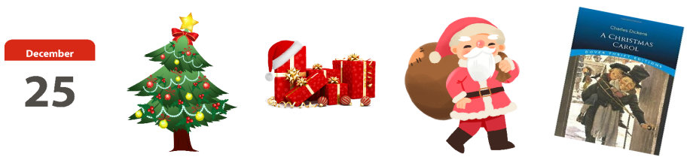 |  |  |  |  |  | To activate Ss’background knowledge about Christmas ,to prepare for the reading；to arouse Ss’interest of learning.  To help Ss to talk about Christmas by asking a question. Then lead in the topic of reading.
Step 2  Presentation | Fast Reading  - Before scanning,  (1)Ask Ss read the title of the passage and ask:What is the spirit of Christmas?  (2)Learn the new words.  - After scanning,  (1)Task 1  Read the passage quickly and match the main idea with each paragraph.  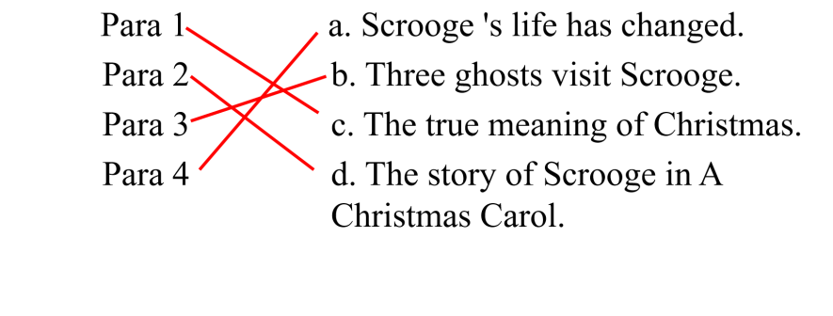(2)Task 2  The general idea of the passage is about____  A. the story of Scrooge.  B. three ghosts of Christmas.  C. the true meaning of Christmas by telling a story.  Careful Reading  1.Read Para 1 carefully.And answer the questions.  Q1. What are the common things that people think of for Christmas?  Q2. What’s the true meaning of Christmas?  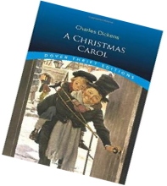  Q3. How does the writer tell the true meaning?  2.Read Para 2 carefully.  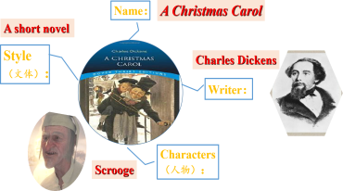  (1) Answer the questions.  Q1.How much do you know about this book?  Q2. From the book,what's Scrooge like?  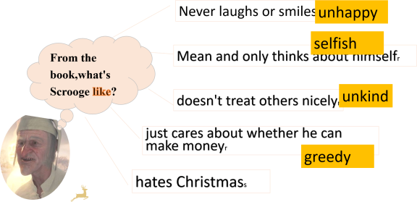  (2)Transition. Do you think Scrooge has any friends?  Q1.Who is Jacob Marlay?  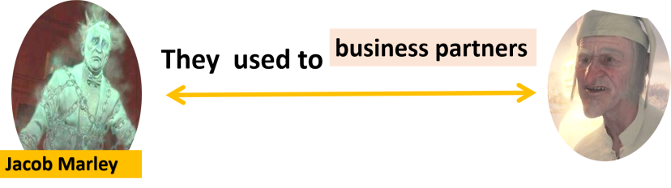  Q2.What happened to Jacob Marley?  Q3.Why was Marley punished after he died?  Ss:Because he used to be just like Scrooge.  (T:What’s the meaning of the word in the passage?)  Q4.Does Jacob Marley want to help Scrooge?Why?  Because he warns Scrooge to change his ways if he doesn’t want to end up like him.  (T:What’s the meaning of the word in the passage?)  Q4:Why did the ghost of Jacob Marley come to visit Scrooge?  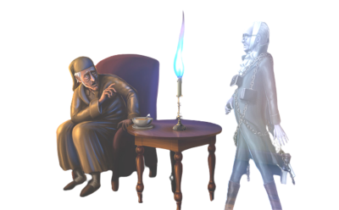  (Watch a video)  Q5.According to Jacob,do you think what the meaning of the word“spirit”is?  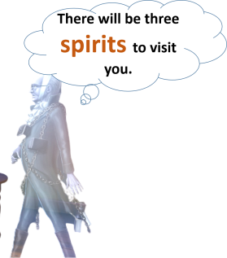  Ghost or the spirit of Christmas?  - Read Para 3 carefully.  Q1.From para 3 ,What are the names of these three ghosts?  Q2.From para 3 ,What does Scrooge see when he's with ghosts? And What is his feeling at that time?  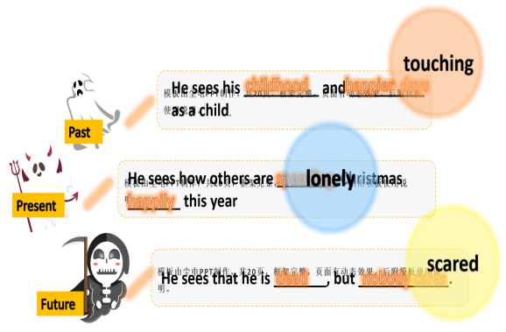  Q3. How does Scrooge feel when he wakes up on Christmas Day?  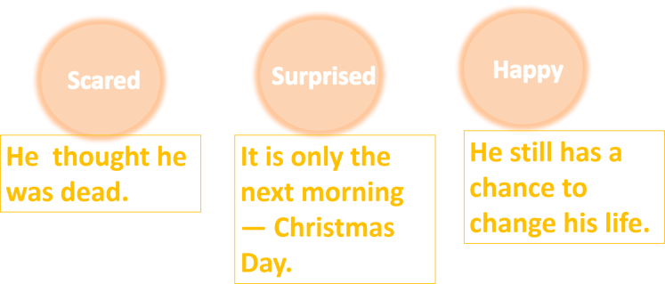  - Read Para 4 carefully.  (1)Answer the questions.  Q1. From Para 4,What does Scrooge do after he wakes up?  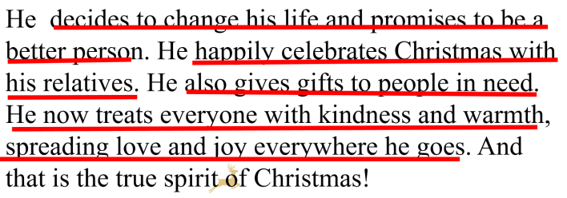  Q2.What do you think of Scrooge?What are the differences between the past and now?  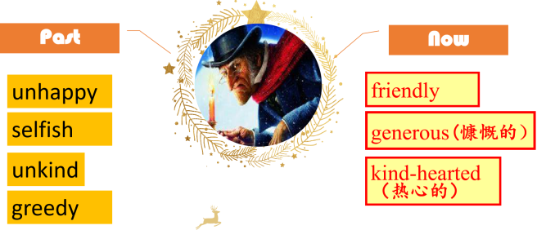  5.Deep thinking.  Q.What is the spirit of Christmas?  Sharing and giving the love and joy to people around us.  6.Emotional sublimation.  - Watch a video: the true love spirit of life  - Treat everyone with kindness and warmth, spreading love and joy everywhere we go.  7. Retell.  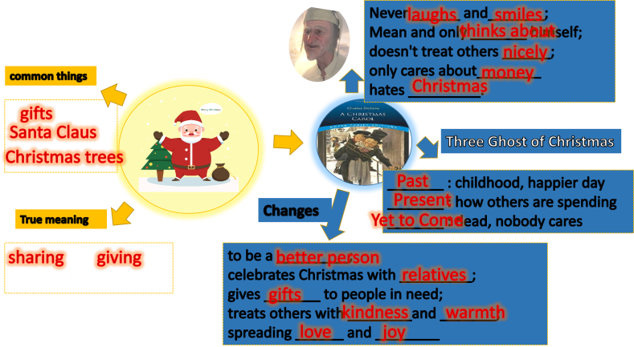 |  |  |  |  |  | Fast reading.  Before reading.To arouse Ss’interest of reading; to guide Ss to pay attention to the topic by ask a question.  To find out the main idea of each paragraph and know about the structure of the passage.To train Ss’reading skills,and help Ss to build up their knowledge hierarchy by themselves.  快速阅读。要求学生在规定的时间能完成了解段落大意，和了解文章的结构。以训练学生的阅读技巧，训练学生去有方向地自主构建知识体系。  To check Ss’ comprehension of Para 1 by asking questions;to help Ss’ pay attention to the key information.  检验学生对Para 1 的理解，帮助学生关注到关键信息。  To help Ss learn the book A Christmas Carol by using the mind map.  使用思维导图帮助学生认识圣诞欢歌这本书。  To help Ss summarize Scrooge’s personality traits.  帮助学生总结Scrooge的性格提点。  To prepare for next activity through transition.通过过渡句为认识Jacob做准备。  To help Ss analyze deeply why Jacob came to visit Scrooge;to help Ss understand the meanings of the two “like”.  帮助学生深度分析为什么Jacob来拜访Scrooge,帮助学生理解两个like的区别。  To help Ss feel about the screen by watching a video;to arouse Ss’ interest of learning.  通过看视频帮助学生感受Jacob 拜访Scrooge的场景，吸引学生的学习兴趣。  To help Ss know about the three ghosts by filling the blanks,and understand Scrooge’s feelings better when he is with the ghosts.  通过填空帮助学生学习这三个鬼魂，也更好的理解当Scrooge被这些鬼魂带去过去，现在和未来的时候的感受。  To help Ss analyze deeply Scrooge’s feelings when he wakes up on Christmas Day.帮助学生分析当Scrooge在圣诞节醒来的时候的感受。  To analyze deeply Scrooge’s change.To liven up the classroom atmosphere by watching a video  深入分析Scrooge的改变,通过看视频再次点燃课堂气氛。  To develop Ss’the ability of thinking,；to echo the previous video；To help form Ss’ emotional attitude.  深入思考。发展学生的思维能力，与前面考生查分的视频前后呼应,情感升华。
五、板书设计（流程）
Unit2 I think that mooncakes are delicious!(Section B (2a-2e)
Reading --- A Christmas Carol
Past Present
Unhappy friendly
A Christmas Carol Carol
Selfish helpful
Unkind kind-hearted
greedy

Teaching reflection:
In this period，the most important thing is reading.It is a good time to train the students' ability of reading quickly and efficiently.Usually we design tasks and get the students to gain skills while finishing these tasks.We deal with the new words and expressions from the Chinese festivals to Western festivals before reading the text.While reading，students should learn to read between the lines to get the meanings that are not clearly stated in the text.Students are supposed to be able to finish the tasks in each paragraph and then learn the whole passage and read aloud.They should sum up the important language items.So the teacher will help them to make a summary of the key points in this class.

