Unit 2 Yes, we can.

Teaching plan

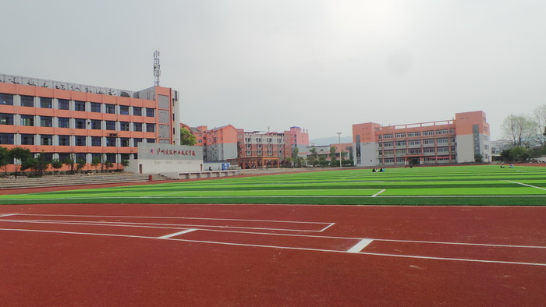

Name：Hu Mingming

School：Luxian Architecture Professional Secondary School

Unit2 Yes，we can.

Lead-in&speaking

|  |  |  |  |  |
| --- | --- | --- | --- | --- |
| **Teaching Class** |  | | **Planned Class Hours** | 40 minutes |
| Teaching  **materials** | English 1 (Basic Course) | | | |
| Analyze learning  contents | 本课时系教材《英语基础教程1》第二单元的第一课时，具体内容为:描述个人能力的词汇、询问和谈论能力的语句。这些内容为整个单元的学习活动做语言和知识的准备，也为学生用英语流利表达个人能力提供了模版，还利于教师挖掘学生的多元智能，学生间进一步促进了解。 | | | |
| Analyze learners | As vocational school students, some of them do not take the initiative to learn English because their English is poor and they don’t know how to communicate in English. | | | |
| Teaching  **objectives** | Knowledge  **objectives** | ⑴ 学生掌握以下词汇和短语：secretary, cook, waiter, typist, taxi driver, nurse, type Chinese words, serve foreign customers, drive a car, cook the meal, look after the patient, write e-mails in English, typing skills, operate the computer, operate office software, send e-mails.  ⑵ 学生掌握询问和描述个人能力时所使用的句型：  -May I have your name, please?  - Can you tell me something about yourself?  - How are your typing skills?  - Can you…?  - I can…  - I am good at… | | |
| Ability  **objectives** | **（**1) 学生能听懂关于询问和描述个人能力的对话；  (2) 学生能罗列个人能力、询问和了解他人的个人能力；  （3）能听懂询问和回答求职面试的简单对话。 | | |
| Emotional  **objectives** | (1) 在谈论职业中，让学生树立正确职业观；  (2) 在模拟职业情境中，培养学生对未来职业的兴趣和憧憬。 | | |
| Important  **points** | 描述个人能力的词汇和句型；  听懂询问和回答个人能力的词汇和句型；  听懂询问和回答求职面试的简单对话。 | | | |
| **Difficulties** | 在模拟或真实语境中谈论个人能力。 | | | |
| **Teaching and learning methods** | Teaching methods:Task-based approach, communicative approach | | | |
| learning methods:Group learning method, Cooperation learning method | | | |
| **Teaching aids** | PPt、Multi-media, blackboard | | | |
| **Procedures and Activities** | | | | |
|  | | | | |

| **Teaching procedures** | **Teaching content** | **Teacher’s activities** | | Students’  **activities** | **design intent** |
| --- | --- | --- | --- | --- | --- |
| **Step1 Lead-in** | 1. A game: Facts or lies 2. Guess: What does he/she do?   3.practice the words and phrases in various farms. | 1. Make a list of abilities, and two of them are lies. Ask the students to pick them out. 2. Show some pictures and ask students to guess. 3. Guide the students to practice the words and phrases. | | 1. Pick out the lies. 2. Guess “What does he/she do?’’ 3. Practice the words and phrases. | Attract students' attention and present the words and phrases naturally, laying the foundation for students' fluent expression. |
| **Step2**  **Listening**  **&**  **speaking** | 1. Listening the dialogue and finish the tasks. 2. Listen and repeat. 3. Role play the dialogue. 4. Look at the pictures and make dialogues. | 1. Let the students listen to the dialogue and figure out the answers. 2. Let students to practice the key sentences:   -May I have your name, please?  - Can you tell me something about yourself?  - How are your typing skills?  - Can you…?  - I can…  - I am good at…   1. Let students to make a role play 2. Ask students to look at the picture and make dialogues. | | 1. Finish the tasks.   2.Make use of the vocabulary and sentence patterns provided in the textbook.   1. Pair work:role play with the partner.   3.Group work: make dialogues. | Help students to practice and consolidate the language knowledge they have learned and master the expressions related to the interview in the professional scene, so as to prepare for the subsequent open activities |
| Step 3  **Production** | 1. Brainstorm:   The ability that a campus tour guide should have.  2.Simulating interview. | 1. Help the students to make a brainstorming. 2. Design a Simulating interview. | | 1. Make a brainstorming. 2. Group work:   Imitate a job interview in groups. | Through this activity, students can make full use of the words and sentence patterns learned in this lesson, and conduct a mock interview according to their own actual situation. In this way, students can initially feel the competition and pressure of the future workplace and enhance their sensitivity to the career. |
| **Step 4 Summary** | Make a summary. | Ask students to conclude what we have learned in this class. | | Recall the knowledge points with the teacher. | Strengthen the memory again. |
| **Homework** | Do an interview | Ask the students to interview their classmates about their abilities. | | Finish the interview. | Consolidate new knowledge; Help students get closer to each other |
| Blackboard  **design** | Unit 2 Yes, we can. | | | | |
| **J**obs:  secretary, cook, waiter, typist, taxi driver, nurse,  Abilities：  type Chinese words, serve foreign customers, drive a car, cook the meal, look after the patient, write e-mails in English, operate office software. | | Key Sentences:  -May I have your name, please?  -Can you tell me something about yourself?  -I can speak…  -How are your…?  -I can type…  -Can you operate…?  -Yes, I can…and…  - I am good at… | | |
| Teaching  reflection |  | | | | |

|  |
| --- |
|  |
|  |

|  |
| --- |
|  |
|  |

|  |
| --- |
|  |

|  |
| --- |
|  |
|  |

|  |
| --- |
|  |

**Unit 2 Yes, we can. 导学案**

**班级：____________ 姓名___________**

1. **Listen and choose.**

(1) Liu Bin can speak English and __________.

A) Japanese B) German C)French D) Korean

(2)Liu Bin can type ________ Chinese words a minute.

A)18 B)28 C) 38 D) 80

1. Liu Bin can send _______________ and operate office software.

A) letters B)e-mails C) notes D) articles

1. **Look at the picture and make a dialogue.**
2. 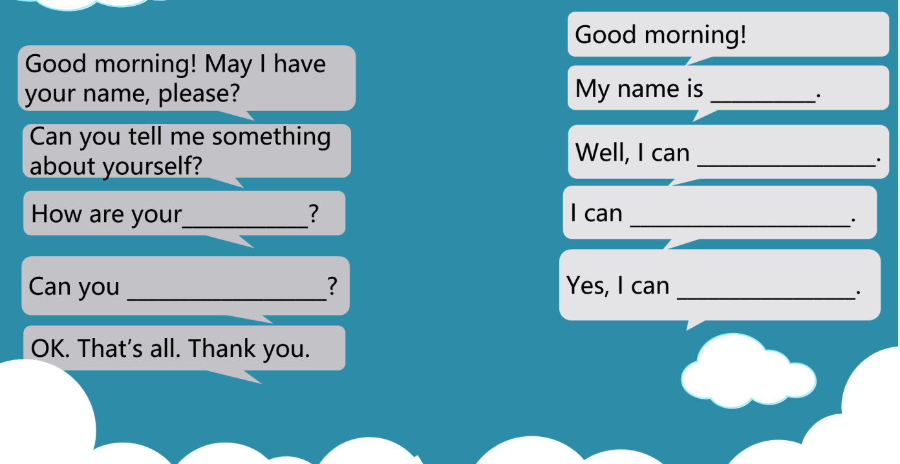**Brainstorm(头脑风暴)**

**Today, there are many teachers coming to our school for the first time. They need a campus guide to introduce the school to them.（今天，有很多老师第一次来电子机械学校，他们需要一名校园导游为他们介绍学校）**

The ability that a campus tour guide should have（校园导游应具备的能力）：

1. **Simulating interview.(模拟面试)**

A: Good morning, _______!

B: Good morning! May I have your name, please?

A: My name is ________________________________________.

B: Can you tell me something about yourself?

A: Well, I can __________________________________________.

B: How are your ________________________________________?

A:I can ________________________________________________.

B: Can you _____________________________________________?

A: Yes, I can ______________________________./I’m good at___________________________.

B: OK. That’s all. Thank you.

**Homework**

**Do an interview (采访班上同学所具备的技能)**

|  |  |
| --- | --- |
| **Name** | **Ability** |
|  |  |
|  |  |
|  |  |
|  |  |
|  |  |